**SYSTEM MANUAL**

**Enigma**



Team Members: Afridi Karim, Ryan Fahnestock, Daniel Campbell, Jackie Yang

**Hardware Requirements**

* CPU: SSE2 instruction set support. Graphics card with DX10 (shader model 4.0) capabilities.
* RAM: 2 GB
* OS: Windows 7 SP1+, macOS 10.12+, Ubuntu 16.04+ 64-bit versions only
* Graphics Card: Graphics card with DX10 (shader model 4.0) capabilities
* Video Card: 128+MB of video memory
* Internet
* Keyboard & Mouse

**Software Requirements**

* Unity3d Version 2019.2.0b3
* Unity Hub 2.0.1
* Any Terminal: Git Bash, Windows Powershell

**Install Guide**

* Download Game files from GitHub.
* Download Unity3D Installer from <https://unity3d.com/get-unity/download>.

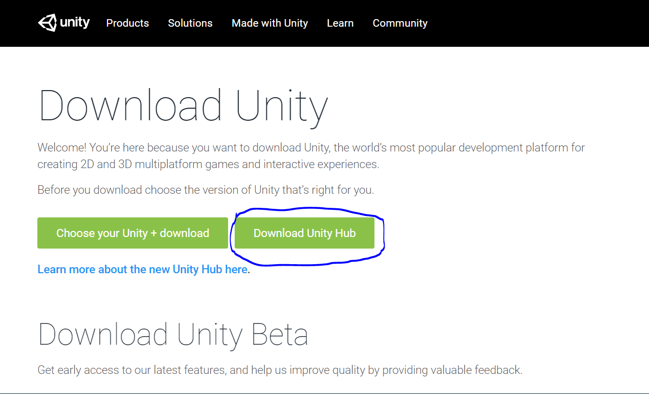

* Install Unity version 2019.2.0b3
* Open the game files *Enigma* in Unity.
* Open the “logo” Scene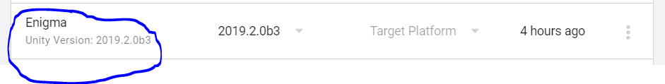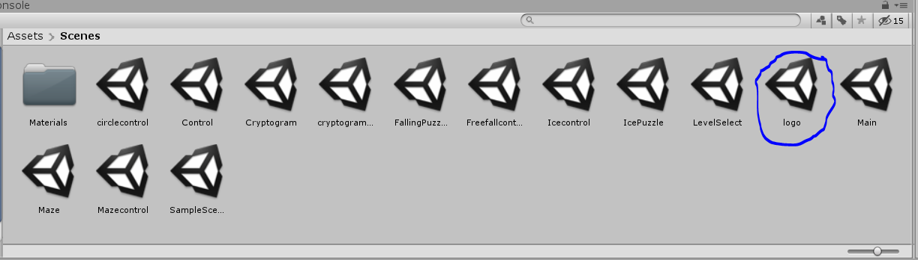
* Click the “Maximize On Play”
* Click the play button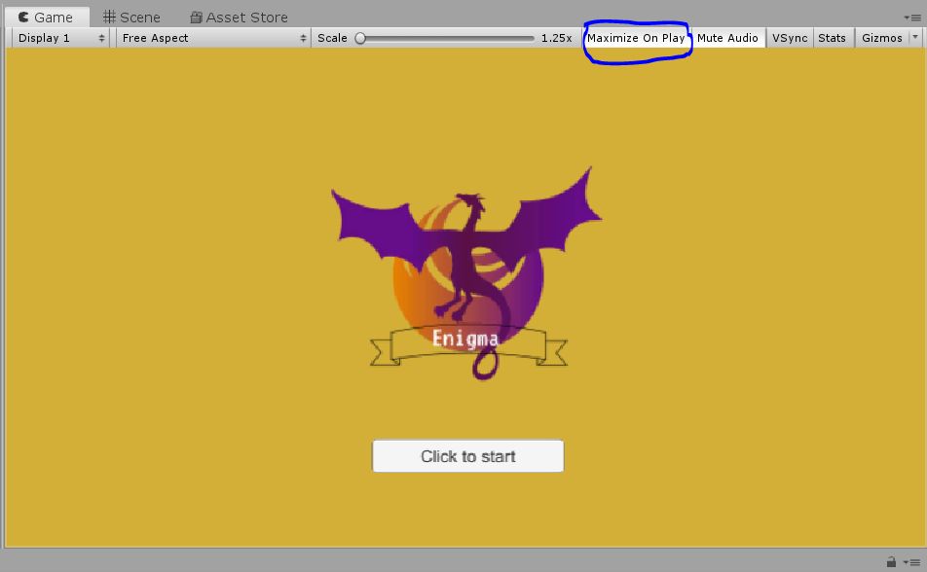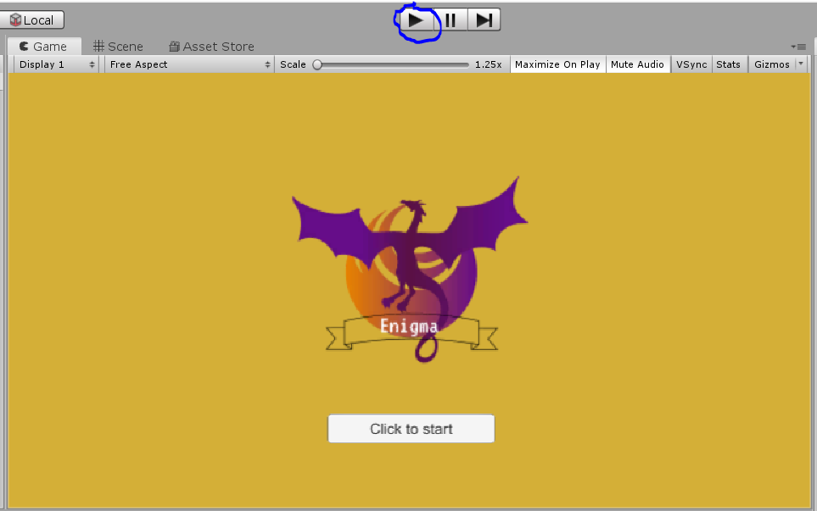

**ERROR Messages**

* Build setting level select not loaded
  + Solution: Open file go to build setting. Add all the scene into “Scenes In Build”. By first manually open each scene then click on “Add Open Scenes” to add scenes to build.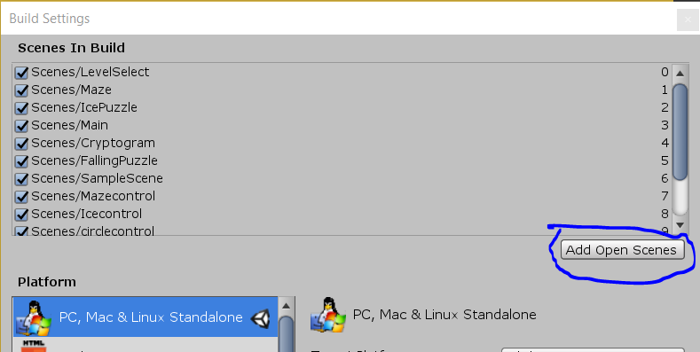

**Troubleshooting**

* Check to make sure Mouse/Keyboard is plugged in.
* Check to make sure the correct Unity version (2019.2.0b3) is installed and in use.
* Exit the program and start the program again.
* Restart computer.
* Contact Developers if the problem persists.

**Contact Information**

Afridi Karim - Project Manager - akk63@drexel.edu

Ryan Fahnestock - Scrum Master - rsf54@drexel.edu

Daniel Campbell - Programmer - dtc53@drexel.edu

Jackie Yang - Programmer - jy532@drexel.edu